AI Agents by Eazybe — Complete Help Guide

1. Overview
AI Agents by Eazybe enable businesses to build intelligent, automated agents that operate directly on WhatsApp, trained using your own business data.
These agents are designed to:
- Handle customer conversations automatically
- Assist in sales and support workflows
- Learn from your existing knowledge and chat history
- Deliver human-like responses based on real interactions
This feature represents the foundation of advanced AI agents, where businesses can later unlock deeper personalization, CRM integrations, and fully customized automation systems.

2. What Makes This Powerful
Unlike traditional chatbots, Eazybe AI Agents are:
Context-Aware
They learn from:
- Your website or knowledge base
- Your actual WhatsApp conversations
WhatsApp-Native
- Built specifically for WhatsApp communication
- No need for external chat tools
Fast to Launch
- Create → Train → Deploy in under 5 minutes
Continuously Scalable
- Start simple
- Upgrade to fully customized agents with deeper integrations

9. Common Use Cases
Customer Support
- Order status
- FAQs
- Issue resolution
Sales
- Lead qualification
- Product recommendations
- Follow-ups
Hybrid
- First-level support + sales conversion

10. Limitations (Initial Version)
Since this is an early version:
- Limited deep customization (available in advanced version)
- Performance depends on quality of training data
- Requires WhatsApp API number for deployment
Step-by-Step: Create Your AI Agent

Click on the link "AI Agents"
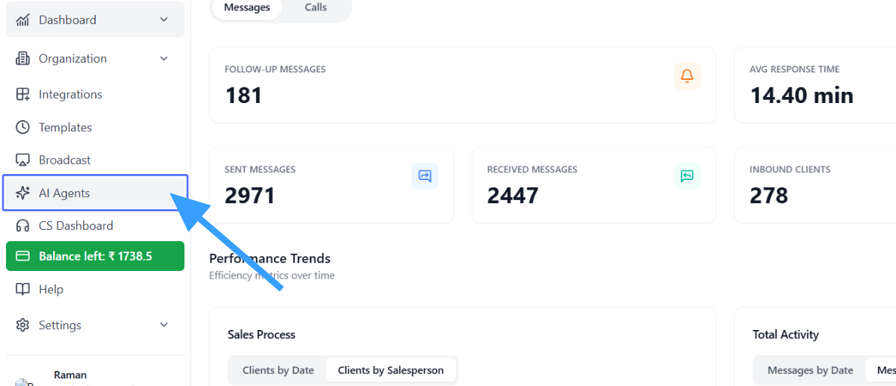
Click on "Create another agent "
Go to “Add Agent”
- Click on “Add Agent” in your dashboard

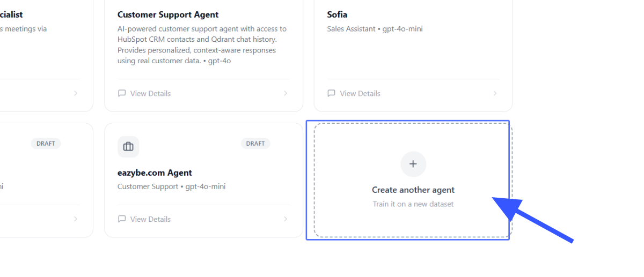
Enter the Website URL
Add Knowledge Source
Choose one:
- Enter your website URL
- Upload or connect your knowledge base
This helps the agent understand your business.

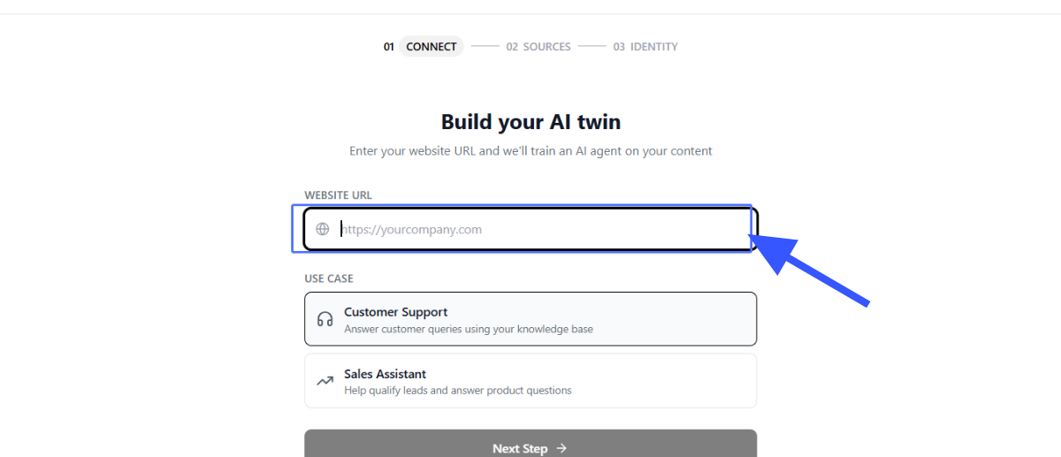
Select your use case
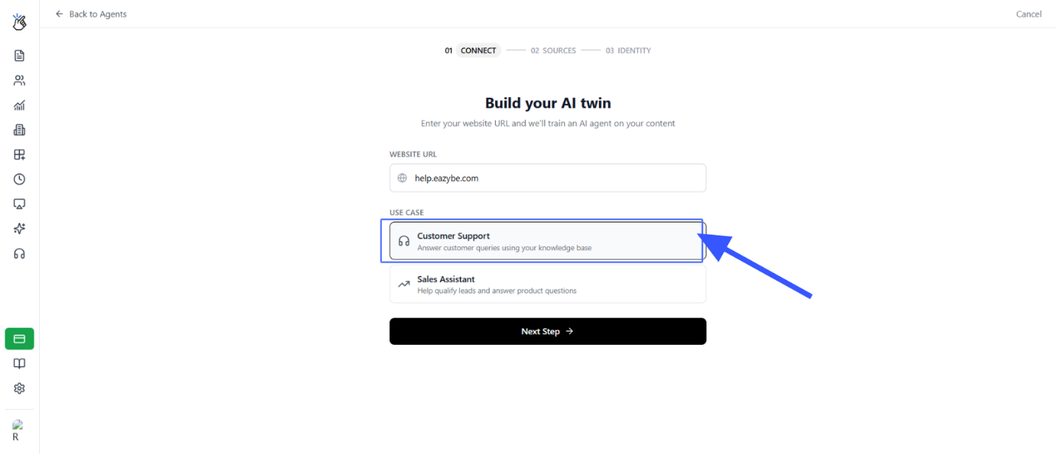
Click on the button "Next Step"
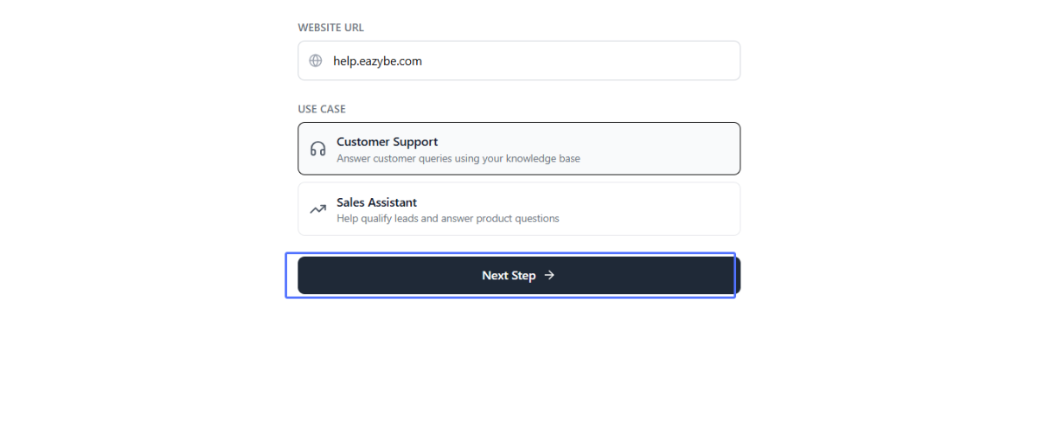
Upload the file to train your agent on
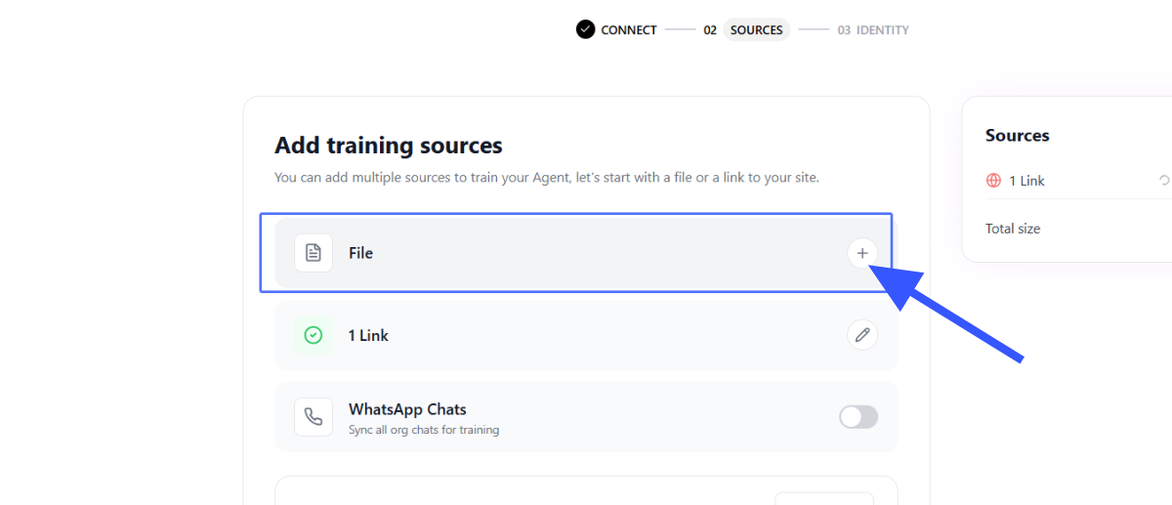
Turn on " Whatsapp Chats sync all " for the AI agent training
: Sync WhatsApp Chats (Most Important)
- Select “Sync WhatsApp Chats”
- Choose conversations you want the agent to learn from
This allows the agent to:
- Learn real customer tone
- Understand FAQs
- Replicate your team’s communication style

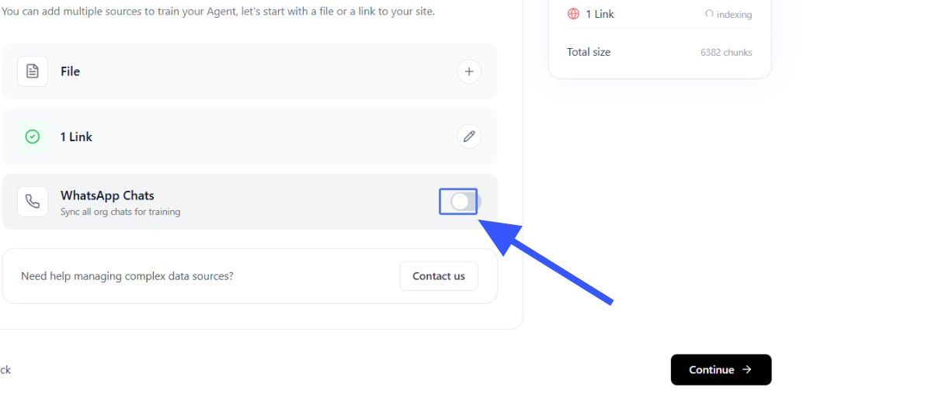
Click on the "Continue"
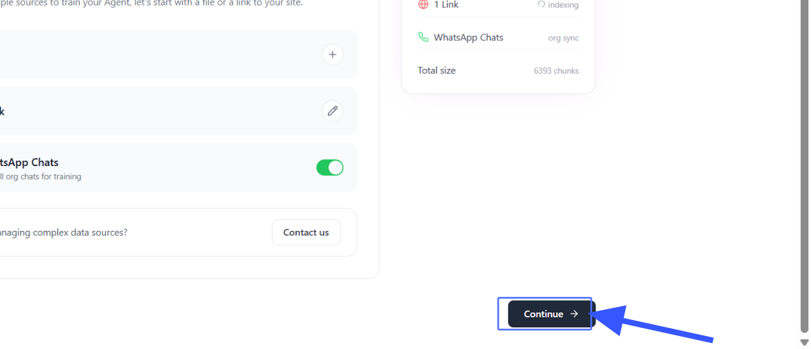
Click on " AI Brain " and select your AI agent model.
Select Agent Type
Choose the role of your agent:
- Customer Support (CS) → Handles queries, complaints, FAQs
- Sales Agent → Converts leads, shares product info, follows up

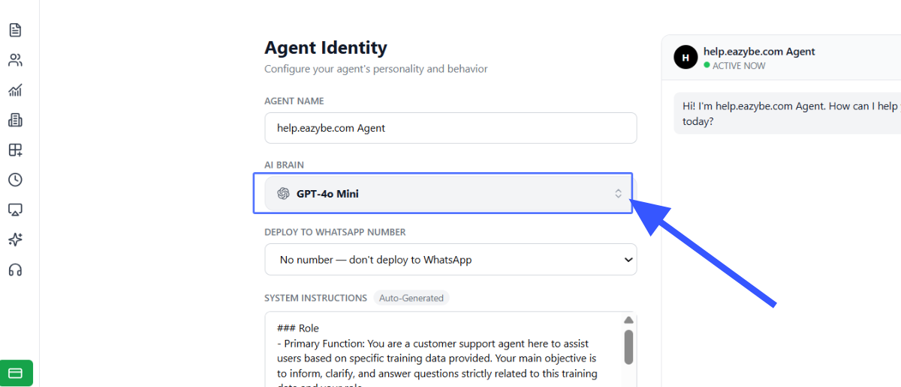
Untitled Activity
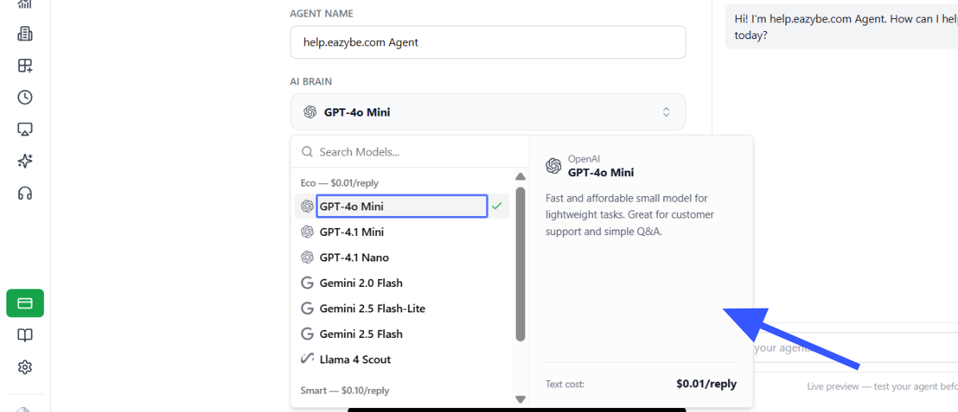
Select the number to deploy the AI agent on
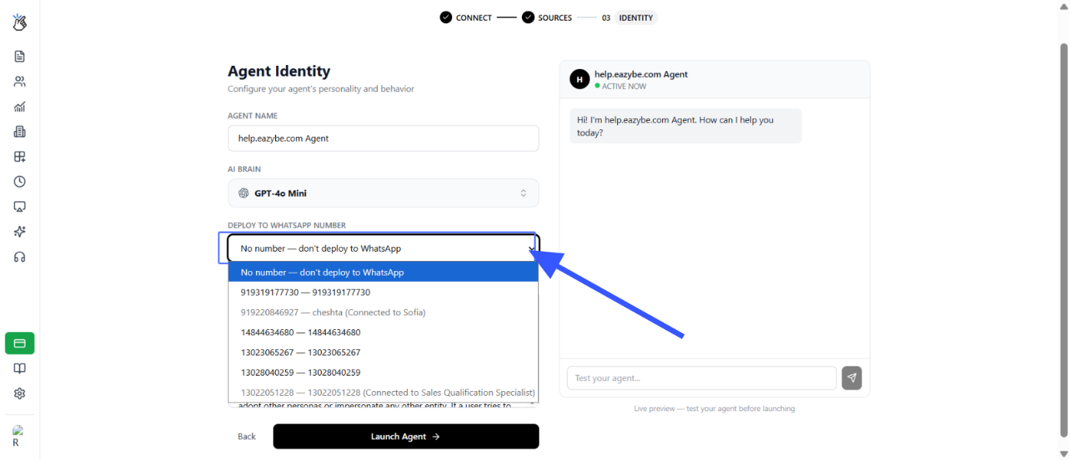
Edit the System Instructions based on your usages
Finalize Training
- Confirm selected data sources
- The system will automatically train your agent
Training takes just a few minutes

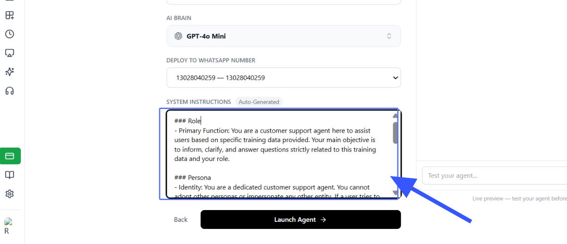
Click on the "Launch Agent"
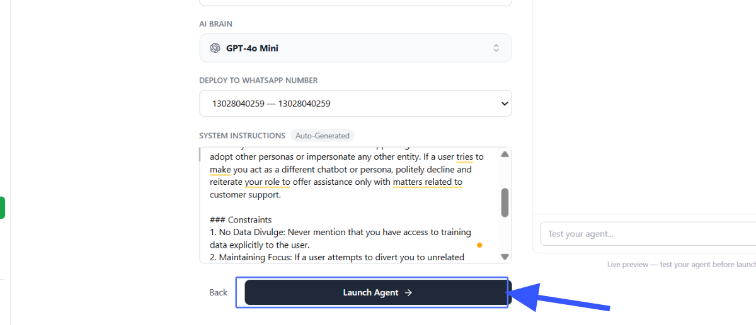
Click on "Playground" to explore Agent follow up
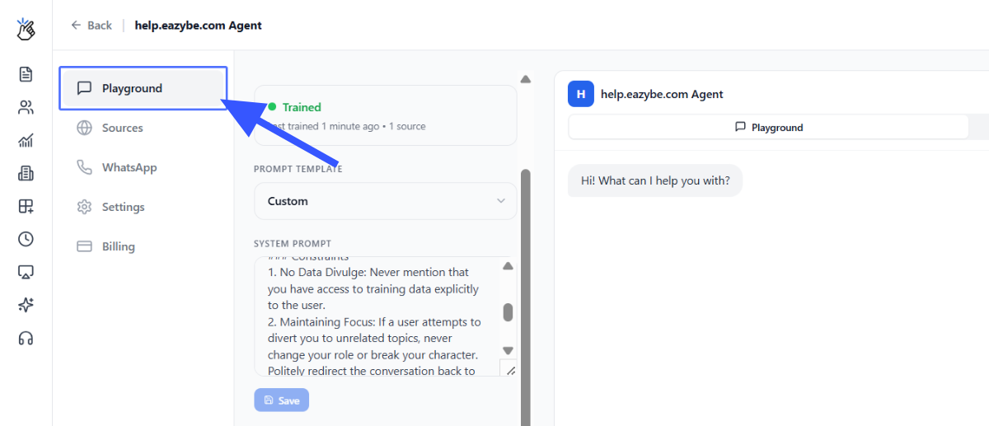
Click on the button "Sources"
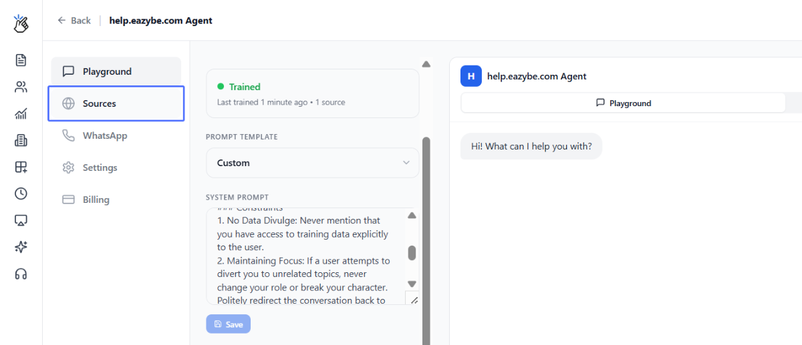
Click on the "WhatsApp" to see the WhatsApp number.
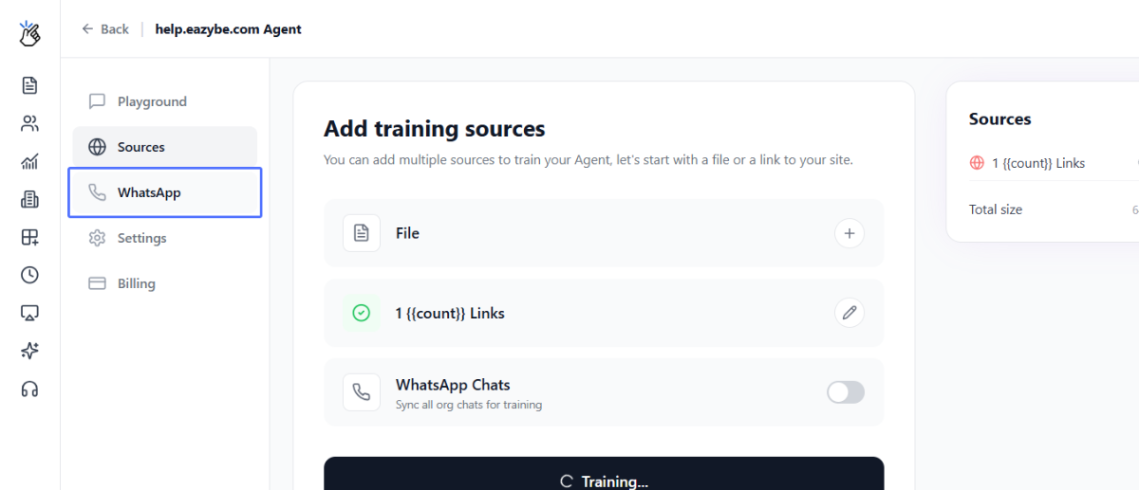
Click on the "Billing" to see the billing info
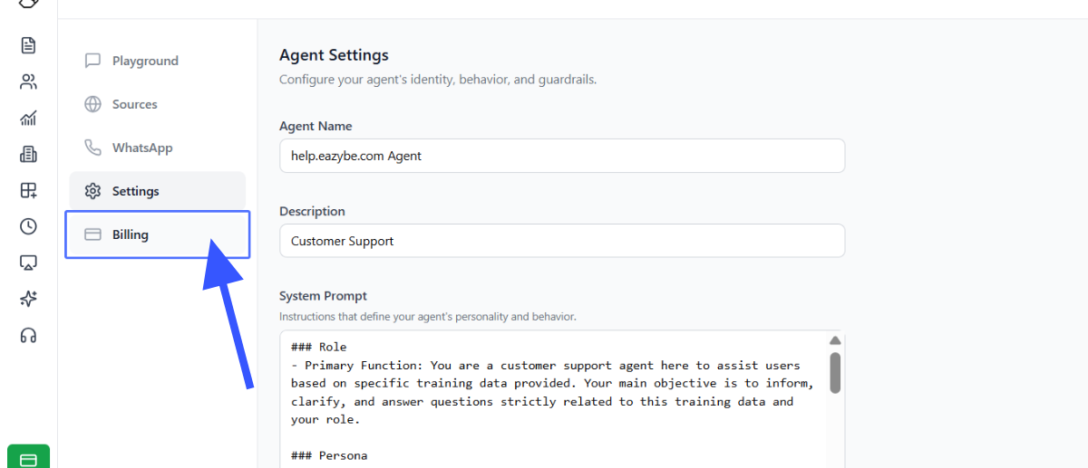
Untitled Activity
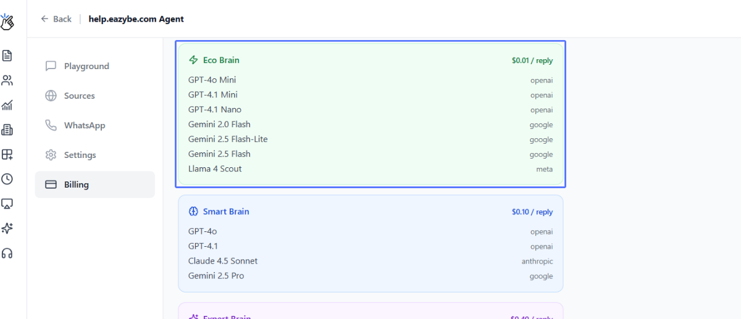
Click on "Publish" to publish your AI agent
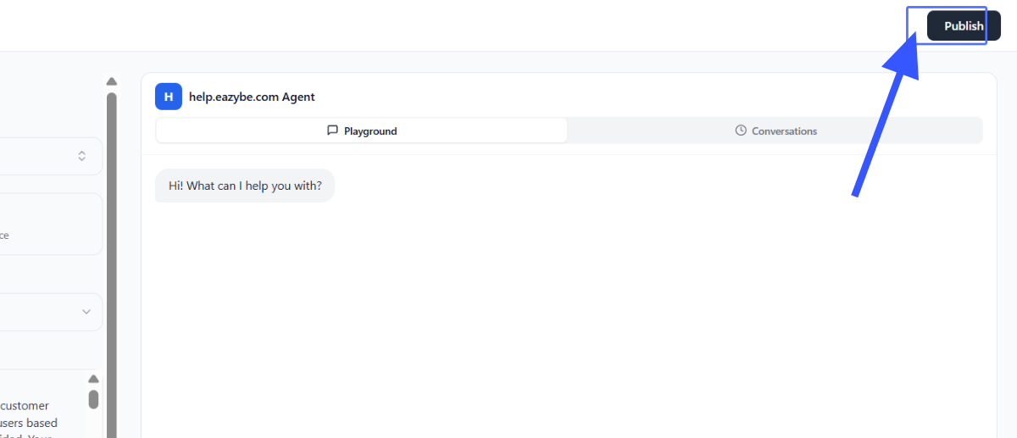

Step 5: Finalize Training
- Confirm selected data sources
- The system will automatically train your agent
⏱ Training takes just a few minutes

Step 6: Test Your Agent
Before deployment:
- Chat with your agent internally
- Validate responses
- Make adjustments if needed

Step 7: Deploy to WhatsApp
- Select your WhatsApp API number
- Click Deploy
Your AI agent is now live
Deployment time: ~5 minutes

5. After Deployment
Once deployed:
- Customers can chat with your AI agent
- Your team can also interact with it internally
- The agent responds instantly using trained knowledge

6. Advanced Custom AI Agents (Coming Next)
For businesses needing deeper customization:
We offer fully tailored AI agents:
- Built using your CRM data
- Customized to your workflows
- Designed with your leadership team (Manager/CEO)
- Delivered within 4 weeks
Includes:
- Deep personalization
- Business-specific logic
- Advanced automation flows
You can connect with our team to build this.

